**Chapter 1**



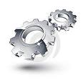

*Mechanics is the branch of* [*physics*](http://en.wikipedia.org/wiki/Physics) *concerned with the behavior of* [*physical bodies*](http://en.wikipedia.org/wiki/Physical_body) *when subjected to* [*forces*](http://en.wikipedia.org/wiki/Force) *or* [*displacements*](http://en.wikipedia.org/wiki/Displacement_(vector))*, and the subsequent effects of the bodies on their environment. During the* [*early modern period*](http://en.wikipedia.org/wiki/Early_modern_period)*, scientists such as* [*Galileo*](http://en.wikipedia.org/wiki/Galileo)*,* [*Kepler*](http://en.wikipedia.org/wiki/Johannes_Kepler)*, and especially* [*Newton*](http://en.wikipedia.org/wiki/Isaac_Newton)*, laid the foundation for what is now known as* [*classical mechanics*](http://en.wikipedia.org/wiki/Classical_mechanics)*.*

*This chapter deals with the detailed description and the contribution of mechanics in robotics.*

Outline:

1. Mechanics

1.0.1Role of mechanics in robotics

1.1Design overview

1.1.1Structural design

1.2Mechanisms and Principles

1.3 Synchronization

*Appendices A. References*

**1.0 MECHANICS**

.

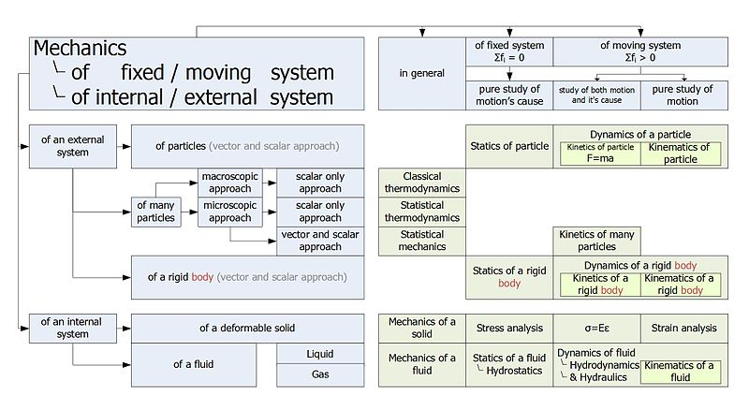

*Fig 1.0 Mechanics block*

**1.0.1 ROLE OF MECHANICS IN ROBOTICS**

Mechanical engineering is a discipline of engineering that applies the principles of physics and materials science for analysis, design, manufacturing, and maintenance of mechanical systems. It is the branch of engineering that involves the production and usage of mechanical power for the design, production, and operation of machines and tools. This field requires an understanding of core concepts including mechanics, kinematics[1], dynamics[2], materials science, and structural analysis. Among these structural analysis of a system plays a vital role in the functioning of the system. Initial planning about the structure is a must before starting the actual work. The structural planning gives the actual degree of accuracy that can be achieved after the complete design of the system .Thus a well designed proper structure can result in a successful working system. In spite of the hardware and software working, there can be discrepancies in the system if the structure is not properly designed.

**1.1 DESIGN OVERVIEW**

**1.1.1Structural Design**

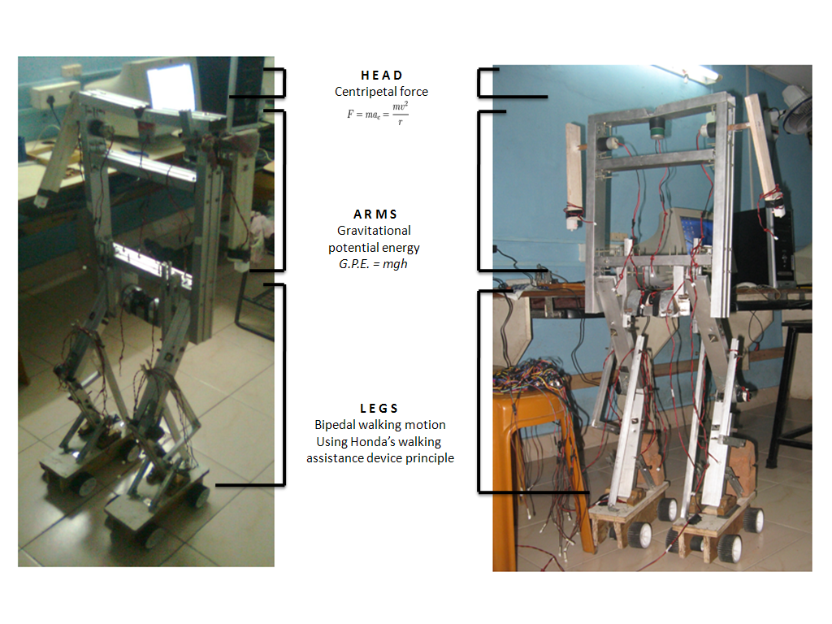

*Fig 1.1 Structural design*

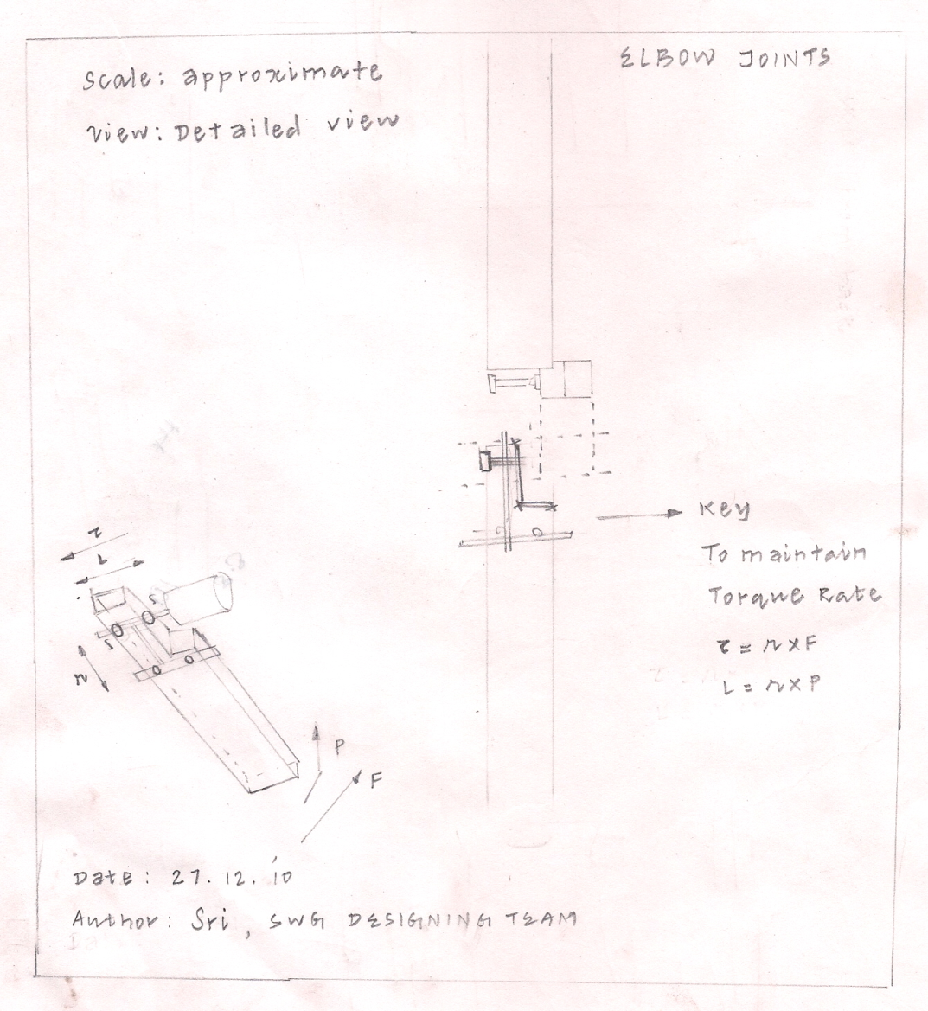

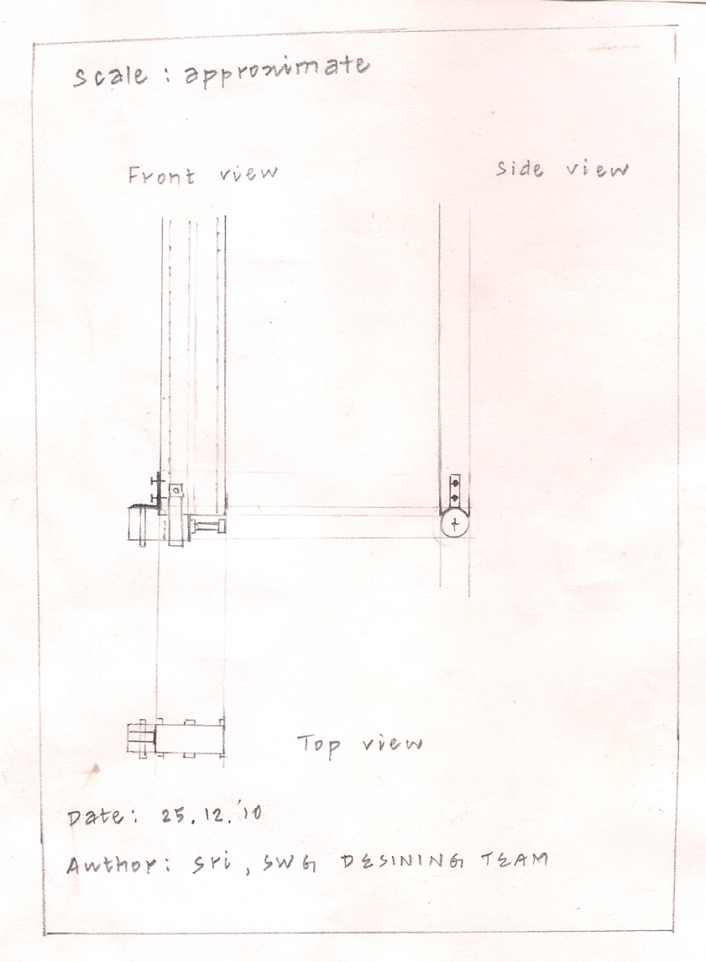

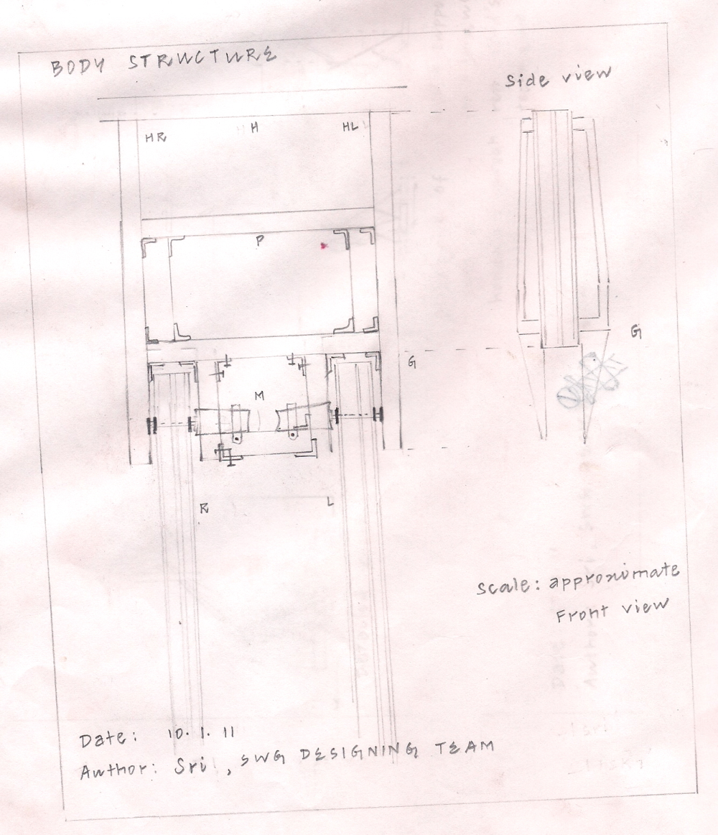

**1.2 MECHANISMS AND PRINCIPLES**

The structure is split into parts

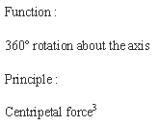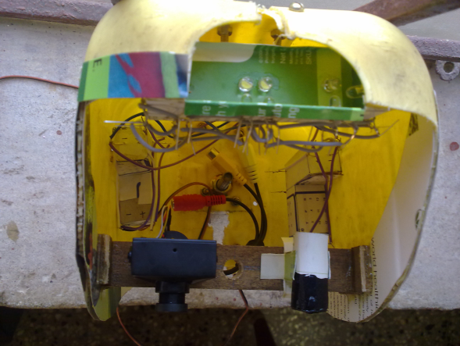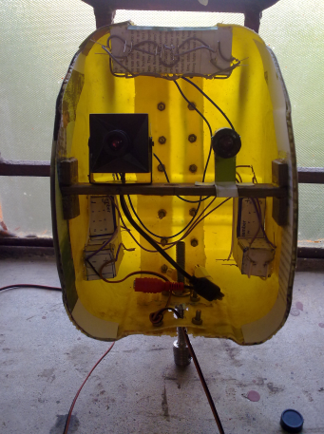**Head [3]**

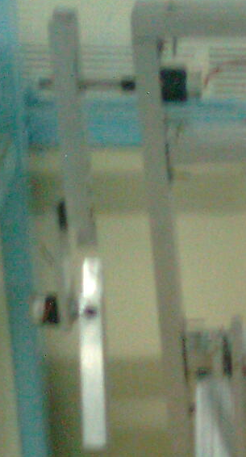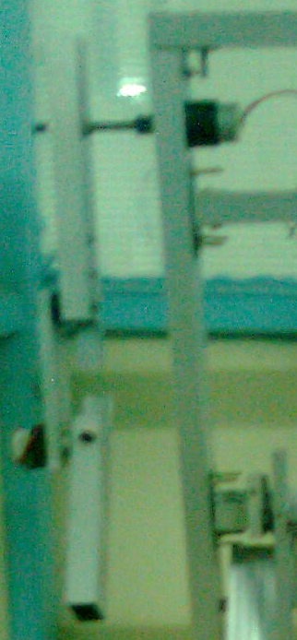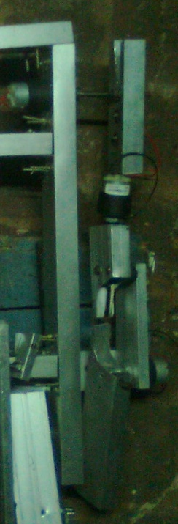**Arms**

Function:

Motion in reference to one axis about any desired direction.

Principle:

The work done against the gravitational force in a vertical distance with some acceleration along the body’s gravitational potential energy (G.P.E)[4]

**Legs**

Function:

Bipedal flexible walk about the horizontal axis

Principle:

Bipedal walking motion[5]

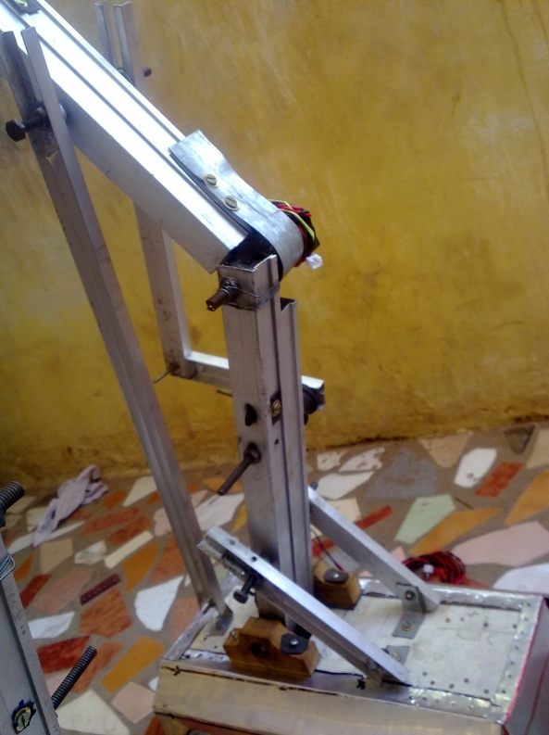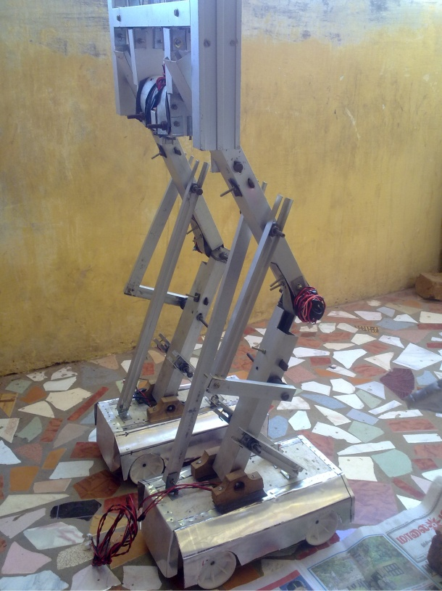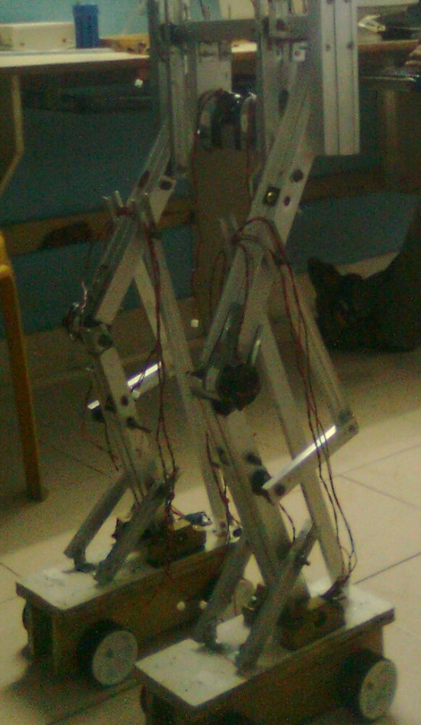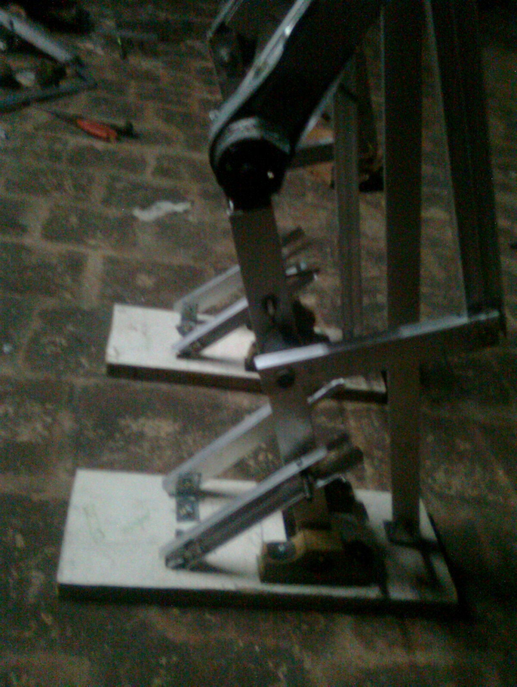

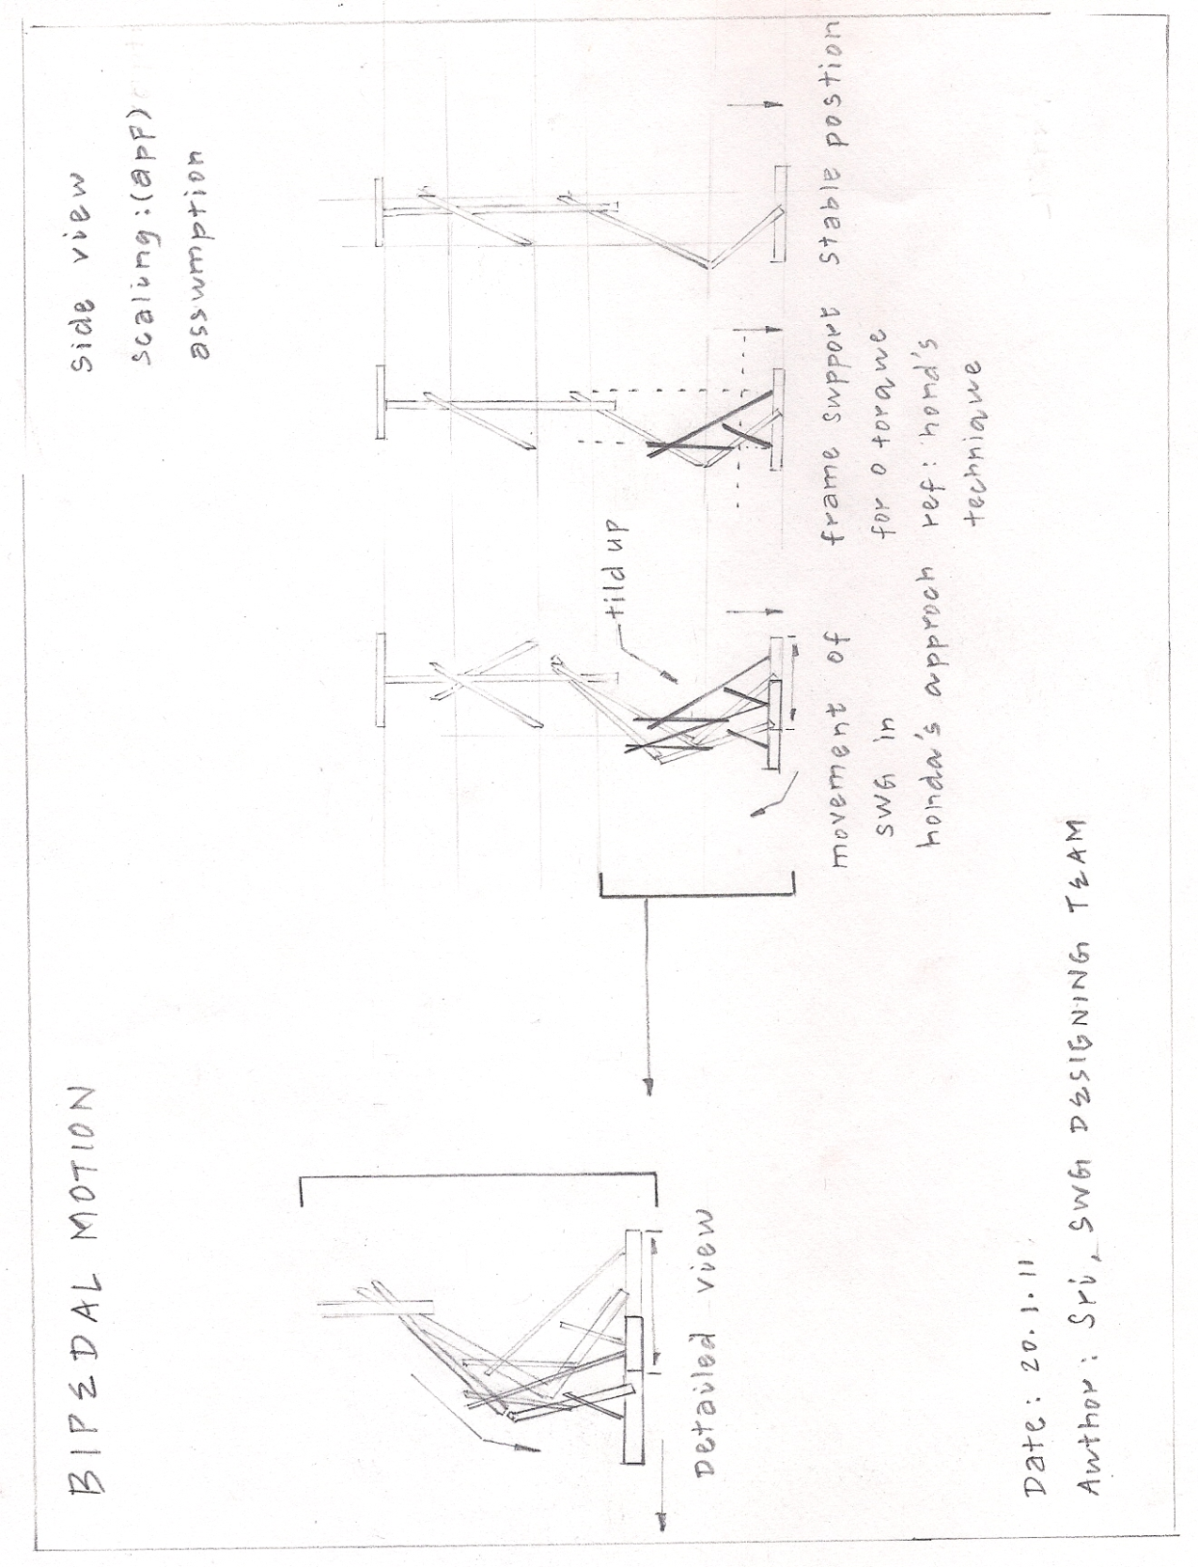**1.3 SYNCRONIZATION**

*Fig 1.2 Synchronization*

1. ***Dynamics*** *is the study of the causes of motion and changes in motion. In other words it is the study of* [*forces*](http://en.wikipedia.org/wiki/Force) *and why objects are in* [*motion*](http://en.wikipedia.org/wiki/Motion_(physics))*. Dynamics includes the study of the effect of torques on motion.* 
2. ***Kinematics*** *is the branch of* [*classical mechanics*](http://en.wikipedia.org/wiki/Classical_mechanics) *that describes the* [*motion*](http://en.wikipedia.org/wiki/Motion_(physics)) *of bodies and systems without consideration of the forces that cause the motion*
3. *Centripetal force is a force that makes a body follow a curved path. 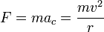*
4. *Gravitational potential energy (G.P.E.) is the energy a body has because of its height above the ground G.P.E. = mgh where h is the height of the body above the ground.* 
5. *Bipedalism is a form of* [*terrestrial locomotion*](http://en.wikipedia.org/wiki/Terrestrial_locomotion) *where an organism* [*moves*](http://en.wikipedia.org/wiki/Motion_(physics)) *by means of its two rear* [*limbs*](http://en.wikipedia.org/wiki/Limbs)*, or* [*legs*](http://en.wikipedia.org/wiki/Legs)*.*